Welcome!
Date
Name
Spouse
Address
City
State Zip _________
Email

Please Contact By
❑ Card  Phone  Visit

Telephone Best Time to Call
Home ______________
Work ______________

Guest: First Time Second Time
Are you a church member: yes no
Church
City, State

Circle Appropriate Age/Grade Group(s)
Preschool: Ages: B-1 2-3 4-5
Children: Grades: K 1 2 3 4 5 6
Youth: Grades: 7 8 9 10 11 12
Adults: Ages:18-29 30s 40s 50s 60s+

How did you learn about our church?
Newspaper Friend Yellow Pages Mail
Other

I am a guest of:

New in the Community? Yes No
Names & ages of children at home
WELCOME NEW MEMBERS:

Ben & Mary Quinn

1663 CR A, Lexington
512-273-2520
CONGRATULATIONS
Cleyon & Geneva Davis:

The adoption of “Nate” by Scott & Stacey is now official & finalized. They are joyfully thanking & praising God.

Weekly Service & Activity Schedule
February 9th, 2014
9:45 a.m. Sunday School
11 a.m. Morning Worship
Baby Shower Honoring Kaidyn Sadler

5:00 p.m. Kids in Action
6:00 p.m. Evening Service & Business Meeting

Week of February 10 – February 15
Wednesday, 6:30 p.m. Youth Activities
Wednesday, 6:45 p.m. Adult Prayer & Bible Study
Wednesday, 7:30 p.m. Praise Team Rehearsal
Friday – Saturday Hot Hearts


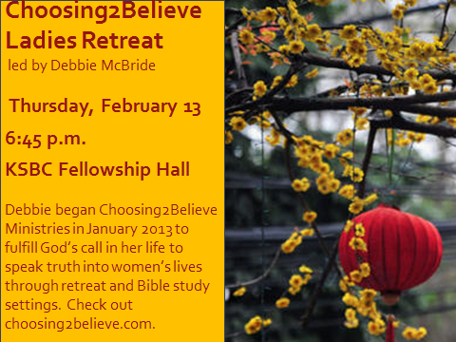

Upcoming Events
February
13 Adult Fellowship
13 Choosing2Believe – Debbie McBride
14 Valentine’s Day
16 Valentine’s BBQ Dinner and Concert
21-22 Ladies Retreat
27 Adult Fellowship

Birthday & Anniversary Recognitions will occur on the final Sunday of each month.

Knobbs Springs Baptist Church

About eight days after Jesus said this, he took Peter,
John and James with him and went up onto a mountain to pray.
As he was praying, the appearance of his face changed, &
his clothes became as bright as a flash of lightning.
Two men, Moses and Elijah, appeared in glorious splendor,
talking with Jesus. They spoke about his departure,
which he was about to bring to fulfillment at Jerusalem.
Peter and his companions were very sleepy, but
when they became fully awake, they saw his glory &
the two men standing with him. As the men were leaving
Jesus, Peter said to him, “Master, it is good for us to be here.
Let us put up three shelters—one for you, one for Moses
and one for Elijah.” (He did not know what he was saying.)
While he was speaking, a cloud appeared and covered them,
and they were afraid as they entered the cloud.
A voice came from the cloud, saying,
“This is my Son, whom I have chosen; listen to him.”
When the voice had spoken, they found that Jesus was alone.
The disciples kept this to themselves and did not
tell anyone at that time what they had seen.

February 9, 2014

Church Information:

KnobbsSpringsBC.com KnobbsSpringsBaptist@gmail.com
1662 CR 305, McDade, Texas 78650 512-273-2743
Brother Dwight Reagan 512-247-6448
Kimberly Tabor, Office Manager 512-698-2804

